JPD-1003
10.1” Rugged Tablet
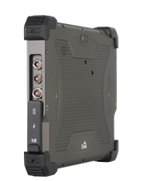
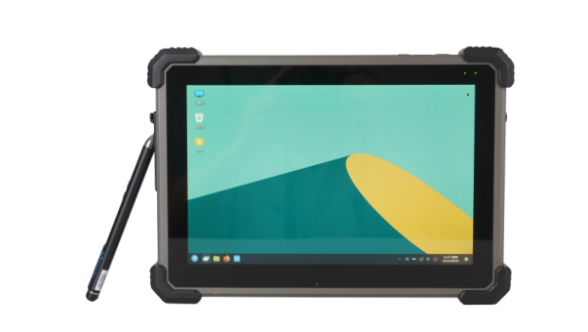
JPD-1003 is a rugged, lightweight, portable, rugged tablet computer with multiple data acquisition functions, designed for harsh environments and outdoor workers. The product integrates various anti-harsh environment characteristics, with robustness, high stability, high reliability, waterproof, dustproof, anti-vibration, anti-drop, anti-salt spray and other product characteristics. The reinforcement index meets a number of industry standards. It meets the requirements of mobile work in harsh outdoor environments, and can be used as an information terminal to undertake multiple application tasks such as communications, surveying and mapping, data acquisition and processing, and is suitable for extreme harsh environments such as the field and on-board vehicles.
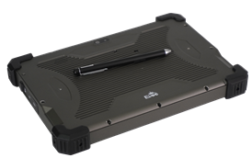

Features:
- 10.1” fully rugged handheld tablet
- Support Win10/Kylin operating system
- Optional active stylus and back hand rest
- Optional WIFI and Bluetooth functions
- Meet military test and IP65, Rich interface, most Aviation connector
- Top structural design scheme and material technology
- Meet multiple industry standards

Specifications
Model | JPD-1003 Rugged Tablet
CPU | Intel® Core™ i7-8665UE 4C8T, 1.7GHz
Display | 10.1” 1280 x 800, sunlight readable  PCAP touch screen, Ratio 16:10  PCAP touch screen
Memory | Onboard 8GB DDR4, support up to 24GB
Storage | 128GB
IO port | 1 x USB 3.0 port (Standard)  1 x USB 2.0 port (Aviation connector)  1 x Gbe (RJ45) (Aviation connector)  1 x Power port (Aviation connector)  1 x COM (Aviation connector)  1 x HDMI (Standard)
Dimension | 264 x 184 x 25mm (exclude buffer corner)
Audio | 1 x Speaker, 1 x Mic
Webcam | 1 x 1200MP rear camera  With flash
Indicator light | Battery charging dual-color (green and red) indicator light, power indicator light
Button | Power button, sound adjustment button
LOGO | Back silk screen EVOC
Battery | 2*4400mAH Li-ion battery
Power Adapter | AC input: 100-240V, output DC19V,90W
OS | Win10/Kylin
Communication | Optional WIFI and Bluetooth functions
Accessories | Optional active stylus and back hand rest
Net weight | About 1.6Kg ( without power supply )

Environmental
Model | JPD-1003 Rugged Tablet
Temperature | Operating Temperature: -20°C to 55°C(Battery power supply), -40°C to 55°C(AC power supply)  Storage Temperature: -40°C to 70°C
Vibration | Meet Industry standard test requirements  Operating: 50-500Hz frequency, 4.2G acceleration  Shock axis: X, Y, Z three axis
Shock | Meet industry standard test requirements  Experimental conditions: power-on state  Operating: peak acceleration 20G, duration 11ms  Axis: ±X, ±Y, ±Z (6 directions)  Times: 3 times/direction
Drop | Meet industry standard test requirements  100CM free drop to hard floor
IP | Meet IP65
EMC | Meet industry standard requirements

Product size chart

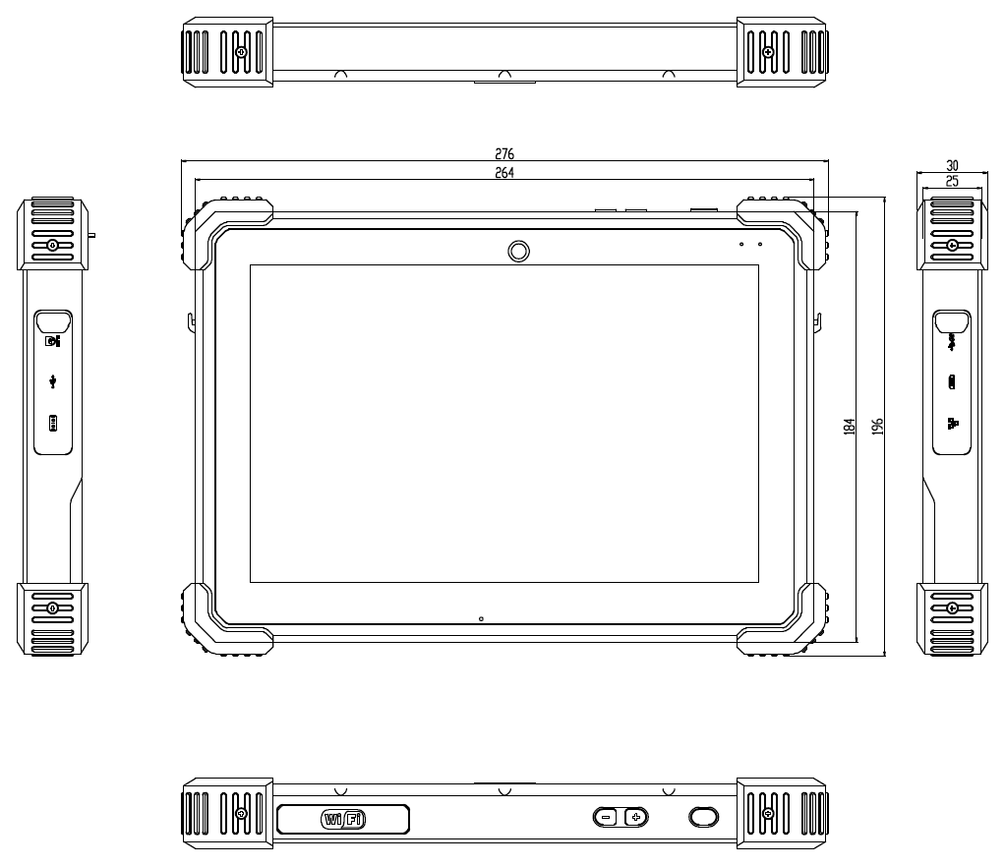
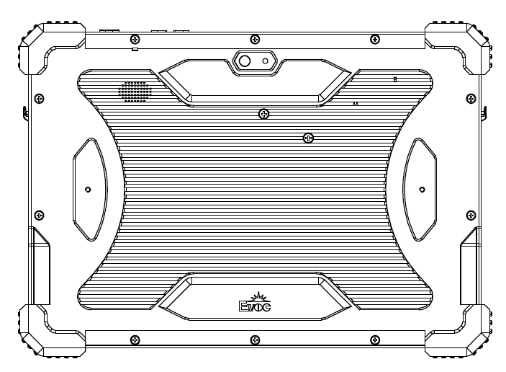

Ordering Information
P/N | Model | Description
0010-151051 | JPD-1003 | Intel Core i7-8665UE 1.7GHz/8GB RAM/128GB storage/10.1” Sunlight Visible/Camera/2*4400mAh/AC power adapter
0010-152271 | JPD-1003-01 | Intel Core i7-8665UE 1.7GHz/8GB RAM/128GB storage/10.1” Sunlight Visible/Camera/2*4400mAh/AC power adapter/ Hand rest/active stylus/wireless/Bluetooth

